Weekly Homework Name ____________________________________
Monday, February 25
Write as a decimal.

3/10 _______ 30/100 _______

7/10 _______ 76/100 _______

Write as a fraction.
0.4 ________ 0.04 __________

.5 _________ .92 ___________

Use two different strategies to show how you can find the quotient for 108 divided by 6.
Strategy 1 Strategy 2

1. 2. 2.

14 + 8 = ____ 14 - 8 = ____

3. 4.
Compare 4/6 and 4/5 by completing the models below.

4/6 ____ 4/5 because _____________________
_______________________________________

Rename each fraction with an equivalent fraction. 1/6 = ______ 6/9 = ______ 4/16 = ______ 7/14 = _____

Tuesday, February 26
Create an area model to find the solution.

146 brownies are packed in boxes of 10. How many boxes are needed to pack all the brownies? _________

146

r = _________
Place the following numbers on the number line below:

.9 0 1.5 1 .09 2

Compare using >, < or =.

.9 _____ 0 0_____ 1.5 1 _____.9

.09 _____.9 2 _____.9 1.5 _____ 2
1. 2.

10

What decimal is shown by the model below? _______

3. 4.
Create a model below to solve:
1 - = _____

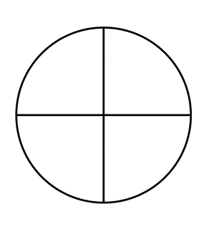

The difference can be named as ____ or ____.

Why are two circles needed?

Weekly Homework Name ____________________________________
Wednesday, February 27
2. Compare by using >, <, or =.

A) .50 _____ .5 B) .85 ____ 85
C) .30 _____ .03 D) .17 ____ 1.7

Draw a model of: 9/4.

1.

3. Use two different strategies to show: 32 x 23 = ______

Strategy 1 Strategy 2

Thursday, February 28
$.48 x 17 = _________

Break the numbers apart to check your answer above.

$.40 x 10 = _____ $.40 x 7 = ______

$.08 x 10 = ______ $.08 x 7= _______

2.
Which expression has the same quotient as 36 ÷ 4?

- 36 ÷ 40 b. 360 ÷ 40

c. 360 ÷ 4 d. 3600 ÷ 4

68 x 100 = _________ 680 x 10 = _________

68 x 1000 = ________ 680 x 100 = _________

What do you notice?

1.

Use either = or ≠ to complete each statement.

42 x 8 ___ (40 + 8) + (2 + 8)

9 + (7 + 6) ___(9 + 7) + 6

502.8 ____ 500 + 20 + 8

.7 x .1 x .5 ___ 1 x 5 x 7

(5 x 20) + (5 x 3)____ 5 x 23

52 – 17 ____ 35 x 1

3.
4. Which expression shows how to use multiplication to check the answer to the division problem?

149 ÷ 7 = ______

- (20 x 7) + 9 = 149
- (21 x 7) + 2 = 149
- (22 x 6) + 17 = 149
- (23 x 5) + 34 = 149

Rename each as a mixed number. 11/6 ______ 15/4 ______ 12/5 ______ 8/3 ______ 7/2 ________

List the first ten prime numbers. ________________________________________________________

