Weekly Homework Name ____________________________________
Tuesday, January 22
Simplify:

12/10 = _______

7/1 = _______

12/15 = ________

1. 2.
Amy walked 5/6 of a mile on Monday, 1/2 mile on Tuesday, and one mile on Wednesday. How far has she walked in three days?

always simplify

– = ________ or __________

Use the model to find the product of:
1/2 x 6/8 = ______
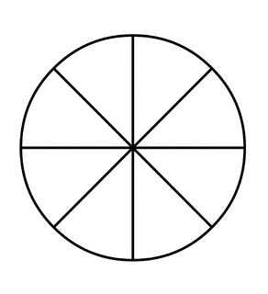

3. 4.

List the first five multiples of 6 and 9. 6 = ___________________________ 9 = _______________________

The LCM for 6 and 9 is ________. When would you use this information? ________________________

Wednesday, January 23
Compare the US dollar to the Euro by completing the chart below.

1 USD = .75 Euro

USD | Euro
$.10
$1 | .75 Euro
$10
$100
$1000
$10,000

Write 5.35 as a mixed number. ____________

Write as a decimal. ___________

1. 2.

Compare using >, <, or =. Prove your answer by making equivalent fractions.

9/4__7/3

Complete the chart by recording the value of each expression.
expression | value
10⁰
10¹
10²
10³
10⁴
10⁵

3. 4. 4.

Circle the numbers divisible by 6. 69 75 173 258 504 552 606 672 713
How do you know?

Weekly Homework Name ____________________________________
Thursday, January 24
2. Charito had a 1/2 bag of M&Ms. She wanted to share them equally among herself and three friends. How much of the bag did each friend get?

1.
Create a model for 3/8 x 2/3. Then record the product below.

3/8 x 2/3 = _______

4. Eduardo is making lemonade. According to his recipe, it takes 3 cups of sugar to make 2 gallons. He only has a 1/4 cup measuring cup. How many 1/4 cup scoops of sugar will he need to measure to make the lemonade?

3.86 x .7 = ________ 3.86 x 7 = _________

3.

Evaluate: 9 x (5 + 3)² – 144 ___________ 7 + 3 x 2⁴ ÷ 6 _________

Just a little extra fun!
1. 2.
The length of a race is 12 miles. The organizers of the race want to provide water stations every 1/3 mile. How many water stations need to be set up for the race?
15 + 6 =

Tamara has 6 yards of ribbon to use in making bows for the Relay for Life fundraiser. She will need to use 1/4 yard for each bow. Which expression below could be used to determine how many bows can she make from the 6 yards of ribbon?

a. ÷ 6 b. 6 x
c. 6 ÷ d. x 6

15 - 6 =

3. 4.

2.7

List all the prime numbers >53 but < 71 _________________________________________________________

